**ACTIVITY 2: SPREADSHEETS**

Find a partner you have not spoken to yet.

You will be assigned a group number.

Complete the following in pairs.

1. Access the google spreadsheet through this link: <https://docs.google.com/spreadsheets/d/1uTnByI_YxszE7hJDFDLLf-pGGBu-WU-W/edit?gid=138968610#gid=138968610>
2. At the bottom of the sheet, find your tab “Group_X” based on what you were assigned. Right click and rename it to your names (E.g. “Raj_and_Anne”)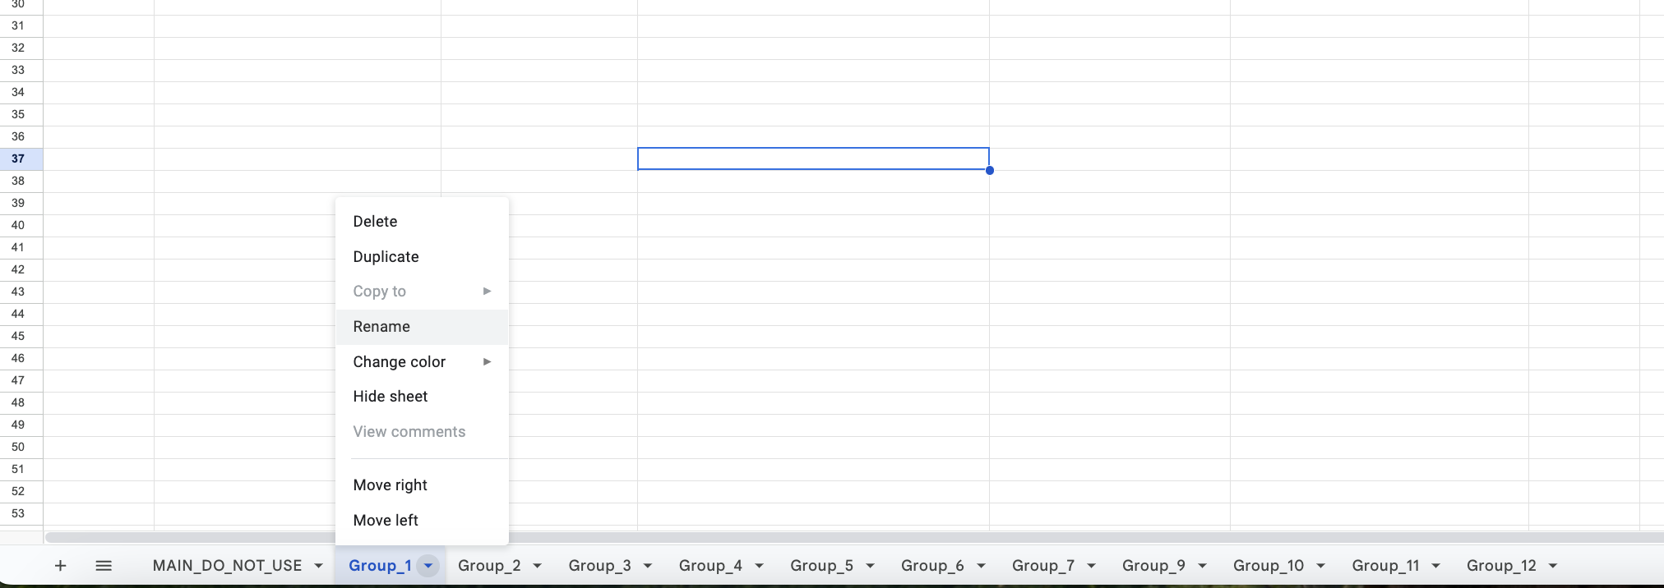
3. You will complete the rest of this activity only in your sheet
4. Fill in the missing blanks in the sheet using Google Maps. Open a web browser (maps.google.com)
   1. Search for addresses that are missing, and add them to the spreadsheet
   2. Search for coordinates that are missing, and add them to the spreadsheet. Right-click on the location on Google Maps to retrieve the coordinates:

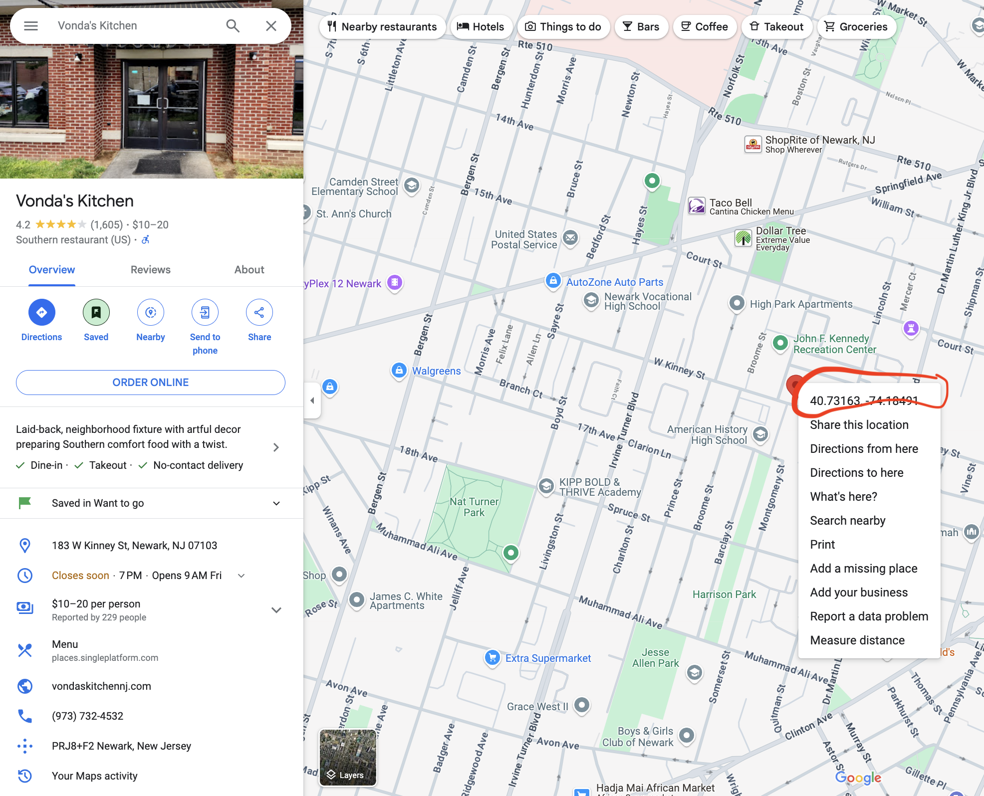

1. HIGHLIGHT all the data in the sheet by pressing “CTRL+A” (Or command + A)
2. SORT data by Latitude by clicking “Data– Sort Range– Advance range sorting options. 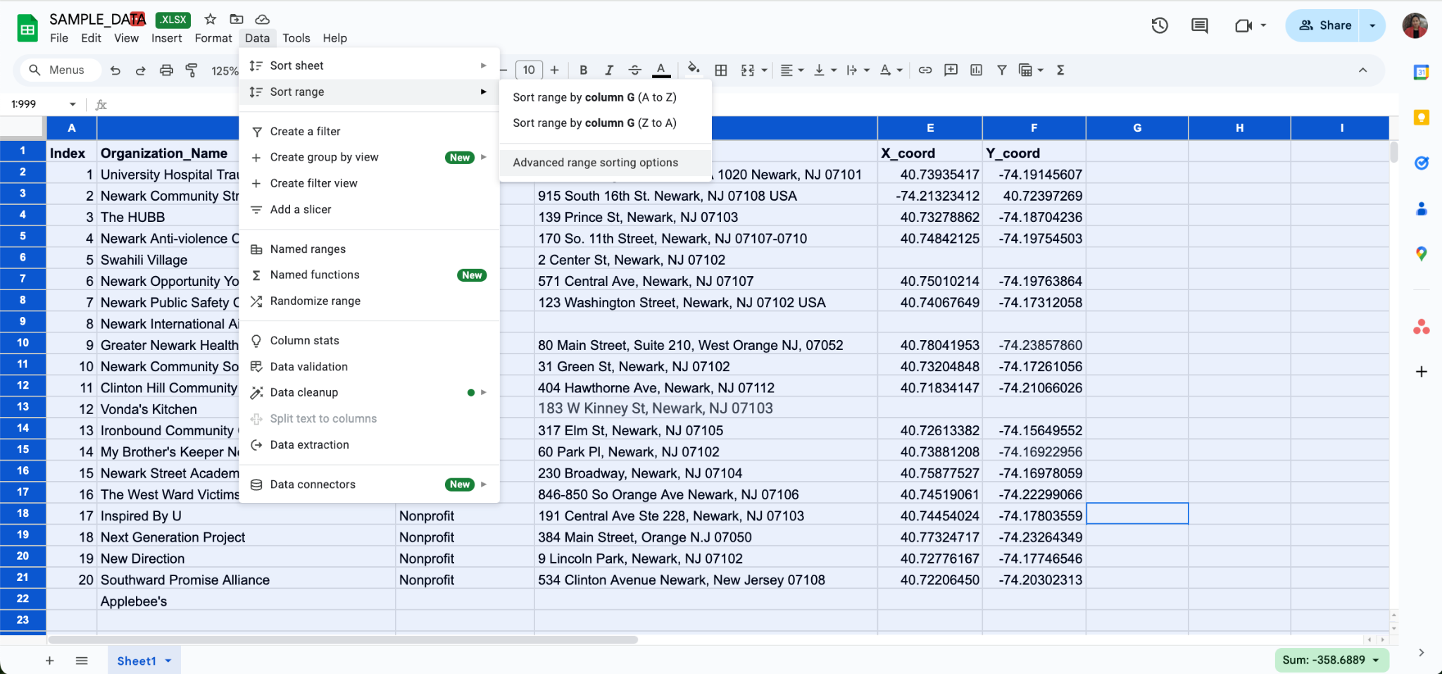
3. Sort by X-coord. Click “Data has header rows” and choose “X_Coord”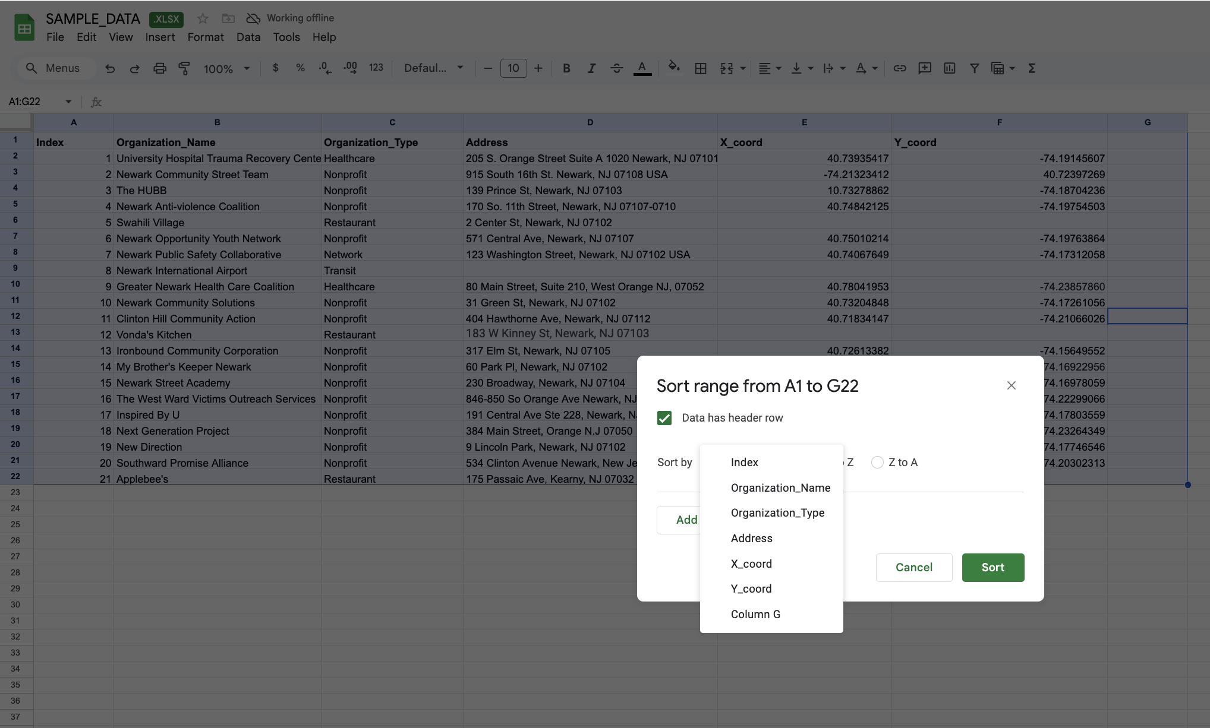
4. Your data should be sorted by the X-coordinate. Does anything look strange? What do you think is wrong?
5. Filter your dataset by “Healthcare”. We want end up with just healthcare organizations. Click on Column C (Organization type) to highlight just the column. Then click “Data-Create a Filter”

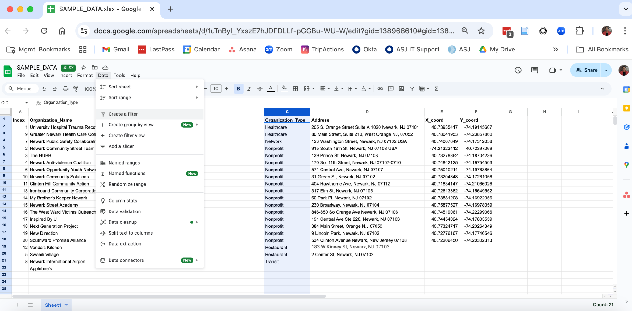

1. Click on the three little lines that appear next to Column C (Organization Type), and unselect everything except “Healthcare”. Then click “OK”.

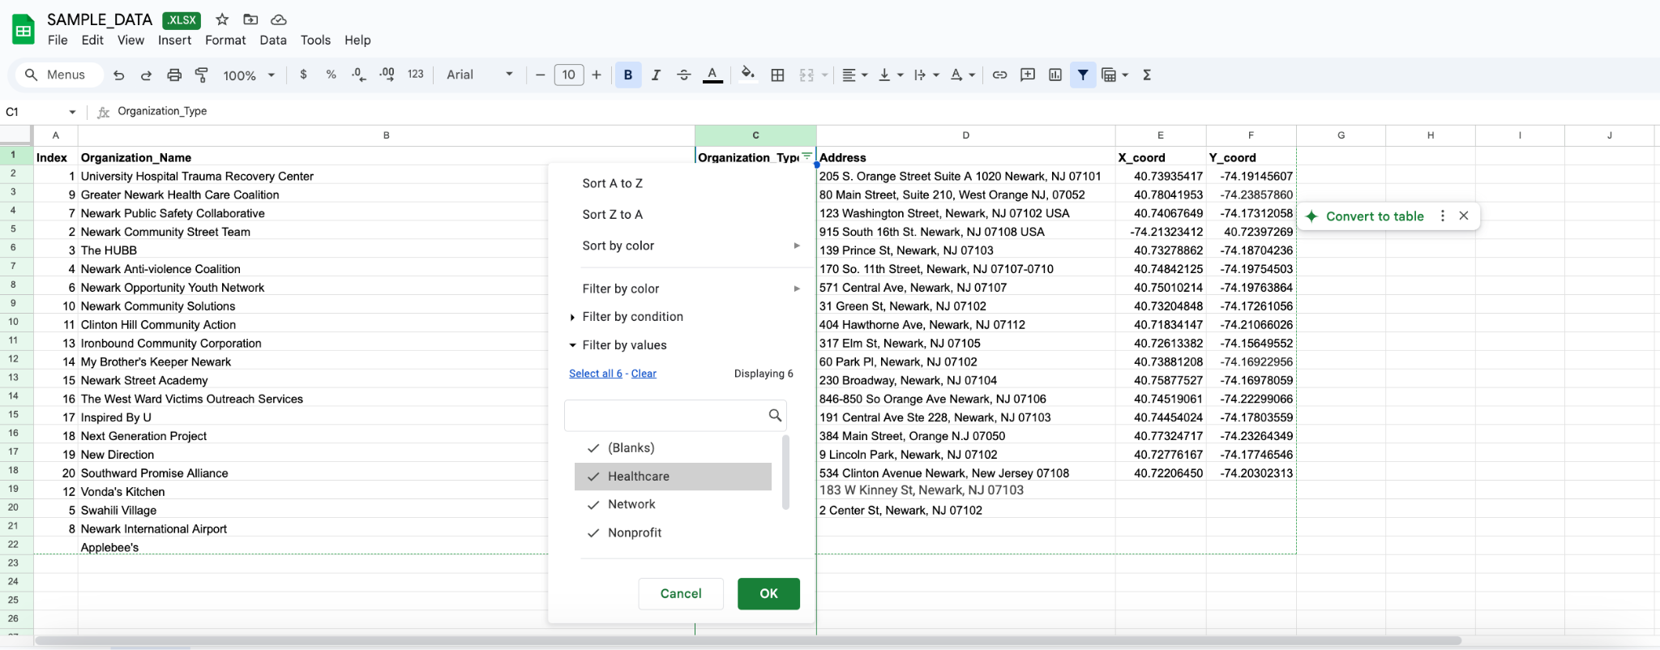

1. You should end up with a dataset that only has two rows of data. Finally, remove the filter by clicking “Data-remove filter”.

**Questions to reflect on and report back to the group:**

* What did you find challenging about this exercise?
* Did you gain any insights into managing and wrangling data?
* Do you think this completed spreadsheet has sufficient information to create a map?